Problema 1.-

**public** **class** Main {

/**

* **@author** Alexander Humberto Nina Pacajes

* 1. -Tenemos el siguiente registro de médicos que trabajan en un hospital:

* a) Mostrar la cantidad de médicos por especialidad

* b) Mostrar a los médicos que tienen más de 2 especialidades

* c) Eliminar al médico con codMedico 987656DFE

*/

**public** **static** **void** main(String[] args) **throws** ClassNotFoundException, IOException {

// **TODO** Auto-generated method stub

ArchMedico m=**new** ArchMedico("Medico.dat");

Scanner lee=**new** Scanner(System.*in*);

**int** op;

**do**{

System.*out*.print(" -- MENU ARCHIVO MEDICO --");

System.*out*.print("\n 1. Crear" +

"\n 2. Adicionar" +

"\n 3. Listar" +

"\n 4. Eliminar" +

"\n 5. Modificar" +

"\n 6. Cantidad de medicos con la especialidad"+

"\n 7. Eliminar medico por codigo");

op=lee.nextInt();

**switch**(op){

**case** 1: m.crear();

**break**;

**case** 2: m.adicionar();

**break**;

**case** 3: m.listar();

**break**;

**case** 4: System.*out*.println("Inttoducir el codigo del Medico");

**if**(m.Eliminar(lee.next()))System.*out*.println("Registro Eliminado");

**else** System.*out*.println("Registro no eliminado");

**break**;

**case** 5: m.Modificar();

**break**;

**case** 6: m.cantMedicosPorEspecialidad();

**break**;

**case** 7: System.*out*.println("Introduce el codigo del medico");

**if**(m.eliminarCodMed(lee.next()))System.*out*.println("Registro eliminado");

**else** System.*out*.println("No existe ese medico");

**break**;

}

**import** java.util.*;

**public** **class** RegMedico **implements** java.io.Serializable{

**private** String nombre;

**private** String codigo;

**private** String especialidad;

**public** String getNombre() {

**return** nombre;

}

**public** **void** setNombre(String nombre) {

**this**.nombre = nombre;

}

**public** String getCodigo() {

**return** codigo;

}

**public** **void** setCodigo(String codigo) {

**this**.codigo = codigo;

}

**public** String getEspecialidad() {

**return** especialidad;

}

**public** **void** setEspecialidad(String especialidad) {

**this**.especialidad = especialidad;

}

**public** **void** leer(){

Scanner lee=**new** Scanner(System.*in*);

System.*out*.println("nombre\tcodigo\tespecialidad");

**this**.nombre=lee.next();

**this**.codigo=lee.next();

**this**.especialidad=lee.next();

}

**public** **void** mostrar(){

System.*out*.println(**this**.nombre+"\t"+**this**.codigo+"\t"+**this**.especialidad);

}

}

**public** **class** ArchMedico {

**private** String nomArch;

**private** RegMedico rMed;

**public** ArchMedico(String nomArch) {

**this**.nomArch = nomArch;

}

**public** **void** crear()**throws** ClassNotFoundException, IOException{

ObjectOutputStream archMed = **new** ObjectOutputStream(**new** FileOutputStream(nomArch));

archMed.close();

}

**public** **void** adicionar()**throws** ClassNotFoundException, IOException{

String op;

Scanner lee = **new** Scanner(System.*in*);

ObjectOutputStream archMed = **null**;

**try**{

**if**(**new** File(nomArch).exists())

archMed = **new** AddObjectOutputStream(**new** FileOutputStream(nomArch,**true**));

**else**

archMed = **new** ObjectOutputStream(**new** FileOutputStream(nomArch,**true**));

**do**{

rMed = **new** RegMedico();

rMed.leer();

archMed.writeObject(rMed);

System.*out*.print("\n Desea Cont. s/n");

op = lee.next();

}**while**(op.equals("s"));

archMed.close();

}**catch**(Exception e){

System.*out*.print("\n FIN ADICIONA");

}

}

**public** **void** listar() **throws** ClassNotFoundException, IOException{

ObjectInputStream archMed =**null**;

**try** {

archMed=**new** ObjectInputStream(**new** FileInputStream(nomArch));

**while**(**true**){

rMed=**new** RegMedico();

rMed = (RegMedico)archMed.readObject();

rMed.mostrar();

}

} **catch** (Exception e) {

System.*out*.println("Fin Listado");

}**finally**{

archMed.close();

}

}

**public** **boolean** Eliminar(String codMed)**throws** ClassNotFoundException,IOException{

**boolean** sw = **false**;

ObjectInputStream archMed = **null**;

ObjectOutputStream aCopia = **null**;

**try** {

archMed = **new** ObjectInputStream(**new** FileInputStream(nomArch));

aCopia = **new** ObjectOutputStream(**new** FileOutputStream("copia.dat",**true**));

**while**(**true**){

rMed = **new** RegMedico();

rMed = (RegMedico)archMed.readObject();

**if**(rMed.getCodigo().equals(codMed))

sw = **true**;

**else**

aCopia.writeObject(rMed);

}

} **catch** (Exception e) {

System.*out*.println("Fin Elimina");

}**finally**{

archMed.close();

aCopia.close();

File f1 = **new** File(nomArch);

File f2 = **new** File("copia.dat");

f1.delete();

f2.renameTo(f1);

}

**return** sw;

}

**public** **void** cantMedicosPorEspecialidad()**throws** ClassNotFoundException,IOException{

System.*out*.println("Introduzca la especialidad a buscar");

Scanner lee=**new** Scanner(System.*in*);

String esp=lee.next();

**int** n=0;

ObjectInputStream archMed = **null**;

ObjectOutputStream aCopia = **null**;

**try** {

archMed = **new** ObjectInputStream(**new** FileInputStream(nomArch));

aCopia = **new** ObjectOutputStream(**new** FileOutputStream("copia.dat",**true**));

**while**(**true**){

rMed = **new** RegMedico();

rMed = (RegMedico)archMed.readObject();

**if**(rMed.getEspecialidad().equals(esp))

n++;

**else**

aCopia.writeObject(rMed);

}

} **catch** (Exception e) {

System.*out*.println("Fin Elimina");

}**finally**{

archMed.close();

aCopia.close();

File f1 = **new** File(nomArch);

File f2 = **new** File("copia.dat");

f1.delete();

f2.renameTo(f1);

}

System.*out*.println("Existen: "+n+" con la expecialidad: "+esp);

}

**public** **boolean** eliminarCodMed(String codMed)**throws** ClassNotFoundException,IOException{

**boolean** sw = **false**;

ObjectInputStream archMed = **null**;

ObjectOutputStream aCopia = **null**;

**try** {

archMed = **new** ObjectInputStream(**new** FileInputStream(nomArch));

aCopia = **new** ObjectOutputStream(**new** FileOutputStream("copia.dat",**true**));

**while**(**true**){

rMed = **new** RegMedico();

rMed = (RegMedico)archMed.readObject();

**if**(rMed.getCodigo().equals(codMed))

sw = **true**;

**else**

aCopia.writeObject(rMed);

}

} **catch** (Exception e) {

System.*out*.println("Fin Elimina");

}**finally**{

archMed.close();

aCopia.close();

File f1 = **new** File(nomArch);

File f2 = **new** File("copia.dat");

f1.delete();

f2.renameTo(f1);

}

**return** sw;

Consola.-

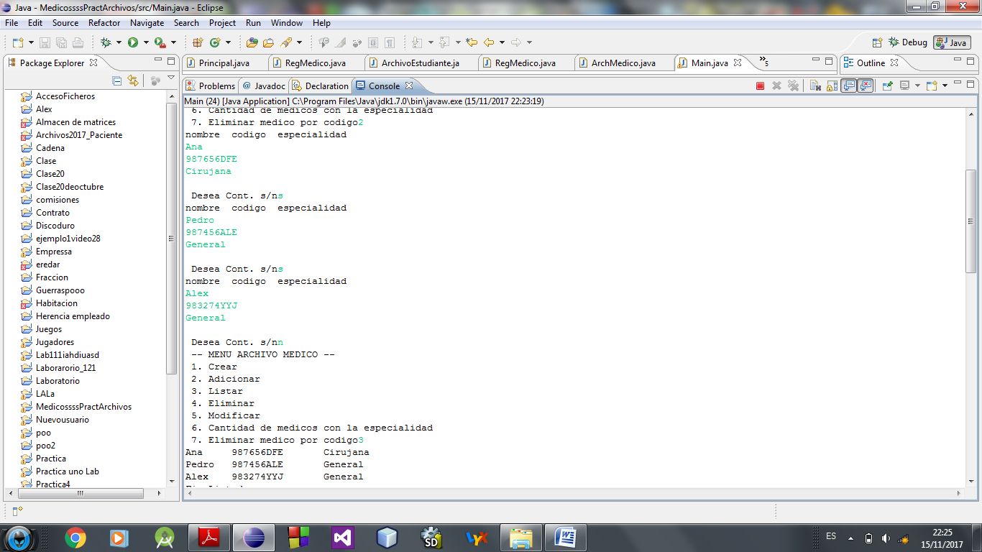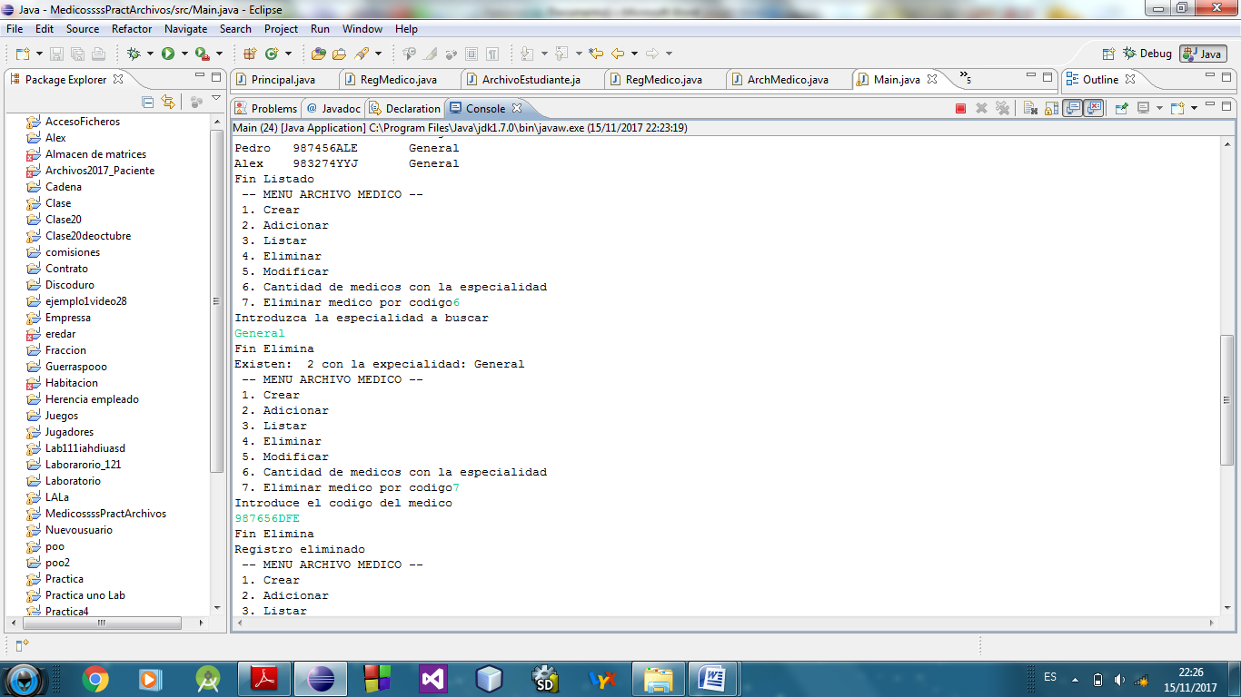

Problema 2.-

**import** java.util.Scanner;

**public** **class** RegCliente **implements** java.io.Serializable {

**private** String codigo;

**private** String na;

**private** **int** edad;

**public** **int** getEdad() {

**return** edad;

}

**public** **void** setEdad(**int** edad) {

**this**.edad = edad;

}

**public** String getCodigo() {

**return** codigo;

}

**public** **void** setCodigo(String codigo) {

**this**.codigo = codigo;

}

**public** String getNa() {

**return** na;

}

**public** **void** setNa(String na) {

**this**.na = na;

}

**public** **void** mostrar() {

System.*out*.println("Nombre: " + **this**.na);

System.*out*.println("Codigo: " + **this**.codigo);

System.*out*.println("Edad: " + **this**.edad);

}

**public** **void** leer() {

Scanner lee = **new** Scanner(System.*in*);

System.*out*.println("Introduce el cod nom edad");

**this**.codigo = lee.next();

**this**.na = lee.next();

**this**.edad = lee.nextInt();

}

}

**public** **class** ArchivoCliente {

**private** String nomArch;

**private** RegCliente rClien;

**public** ArchivoCliente(String nomArch) {

**this**.nomArch = nomArch;

}

**public** **void** crear()**throws** ClassNotFoundException, IOException{

ObjectOutputStream archMed = **new** ObjectOutputStream(**new** FileOutputStream(nomArch));

archMed.close();

}

**public** **void** adicionar()**throws** ClassNotFoundException, IOException{

String op;

Scanner lee = **new** Scanner(System.*in*);

ObjectOutputStream archClien = **null**;

**try**{

**if**(**new** File(nomArch).exists())

archClien = **new** AddObjectOutputStream(**new** FileOutputStream(nomArch,**true**));

**else**

archClien = **new** ObjectOutputStream(**new** FileOutputStream(nomArch,**true**));

**do**{

rClien = **new** RegCliente();

rClien.leer();

archClien.writeObject(rClien);

System.*out*.print("Desea Cont. s/n");

op = lee.next();

}**while**(op.equals("s"));

archClien.close();

}**catch**(Exception e){

System.*out*.print("\n FIN ADICIONA");

}

}

**public** **void** listar() **throws** ClassNotFoundException, IOException{

ObjectInputStream archClien =**null**;

**try** {

archClien=**new** ObjectInputStream(**new** FileInputStream(nomArch));

**while**(**true**){

rClien=**new** RegCliente();

rClien = (RegCliente)archClien.readObject();

rClien.mostrar();

}

} **catch** (Exception e) {

System.*out*.println("Fin Listado");

}**finally**{

archClien.close();

}

}

**public** **boolean** Eliminar(String codMed)**throws** ClassNotFoundException,IOException{

**boolean** sw = **false**;

ObjectInputStream archClien = **null**;

ObjectOutputStream aCopia = **null**;

**try** {

archClien = **new** ObjectInputStream(**new** FileInputStream(nomArch));

aCopia = **new** ObjectOutputStream(**new** FileOutputStream("copia.dat",**true**));

**while**(**true**){

rClien = **new** RegCliente();

rClien = (RegCliente)archClien.readObject();

**if**(rClien.getCodigo().equals(codMed))

sw = **true**;

**else**

aCopia.writeObject(rClien);

}

} **catch** (Exception e) {

System.*out*.println("Fin Elimina");

}**finally**{

archClien.close();

aCopia.close();

File f1 = **new** File(nomArch);

File f2 = **new** File("copia.dat");

f1.delete();

f2.renameTo(f1);

}

**return** sw;

}

**public** **void** Modificar()**throws** ClassNotFoundException,IOException{

Scanner lee = **new** Scanner(System.*in*);

System.*out*.println("Intr. cod a modificar");

String op, codMed = lee.next();

ObjectInputStream archClien = **null**;

ObjectOutputStream aCopia = **null**;

**try** {

archClien = **new** ObjectInputStream(**new** FileInputStream(nomArch));

aCopia = **new** ObjectOutputStream(**new** FileOutputStream("copia.dat",**true**));

**while**(**true**){

rClien = **new** RegCliente();

rClien = (RegCliente)archClien.readObject();

**if**(rClien.getCodigo().equals(codMed)){

rClien.mostrar(); System.*out*.println("Desea modificar s/n");

op = lee.next();

**if**(op.equals("s")){

rClien.leer();

rClien.mostrar();

}

}

aCopia.writeObject(rClien);

}

} **catch** (Exception e) {

System.*out*.println("Fin modifica");

}**finally**{

archClien.close(); aCopia.close();

File f1 = **new** File(nomArch); File f2 = **new** File("copia.dat");

f1.delete(); f2.renameTo(f1);

}

}

}

**import** java.util.Scanner;

**public** **class** RegSolicitud **implements** java.io.Serializable{

**private** String idSolicitud;

**private** String []libros=**new** String [10];

**private** String idCliente;

**public** String getIdSolicitud() {

**return** idSolicitud;

}

**public** **void** setIdSolicitud(String idSolicitud) {

**this**.idSolicitud = idSolicitud;

}

**public** String[] getLibros() {

**return** libros;

}

**public** **void** setLibros(String[] libros) {

**this**.libros = libros;

}

**public** String getIdCliente() {

**return** idCliente;

}

**public** **void** setIdCliente(String idCliente) {

**this**.idCliente = idCliente;

}

**public** **void** mostrar(){

System.*out*.println("id solicitud: "+**this**.idSolicitud);

System.*out*.println("libros");

**for** (**int** i = 0; i < **this**.libros.length; i++) {

System.*out*.println("Libro"+(i+1)+" : "+**this**.libros[i]);

}

System.*out*.println("id Cliente; "+**this**.idCliente);

}

**public** **void** leer(){

Scanner lee=**new** Scanner(System.*in*);

System.*out*.println("introduzca datos");

**this**.idSolicitud=lee.next();

**int** a=lee.nextInt();

**for** (**int** i = 0; i < a; i++) {

**this**.libros[i]=lee.next();

}

**this**.idCliente=lee.next();

}

}

**public** **class** ArchivoSolicitud {

**private** String nomArch;

**private** RegSolicitud rSol;

**public** ArchivoSolicitud(String nomArch) {

**this**.nomArch = nomArch;

}

**public** **void** crear()**throws** ClassNotFoundException, IOException{

ObjectOutputStream archSol = **new** ObjectOutputStream(**new** FileOutputStream(nomArch));

archSol.close();

}

**public** **void** adicionar()**throws** ClassNotFoundException, IOException{

String op;

Scanner lee = **new** Scanner(System.*in*);

ObjectOutputStream archSol = **null**;

**try**{

**if**(**new** File(nomArch).exists())

archSol = **new** AddObjectOutputStream(**new** FileOutputStream(nomArch,**true**));

**else**

archSol = **new** ObjectOutputStream(**new** FileOutputStream(nomArch,**true**));

**do**{

rSol = **new** RegSolicitud();

rSol.leer();

archSol.writeObject(rSol);

System.*out*.print("Desea Cont. s/n");

op = lee.next();

}**while**(op.equals("s"));

archSol.close();

}**catch**(Exception e){

System.*out*.print("\n FIN ADICIONA");

}

}

**public** **void** listar() **throws** ClassNotFoundException, IOException{

ObjectInputStream archSol =**null**;

**try** {

archSol=**new** ObjectInputStream(**new** FileInputStream(nomArch));

**while**(**true**){

rSol=**new** RegSolicitud();

rSol = (RegSolicitud)archSol.readObject();

rSol.mostrar();

}

} **catch** (Exception e) {

System.*out*.println("Fin Listado");

}**finally**{

archSol.close();

}

}

**public** **boolean** Eliminar(String codMed)**throws** ClassNotFoundException,IOException{

**boolean** sw = **false**;

ObjectInputStream archSol = **null**;

ObjectOutputStream aCopia = **null**;

**try** {

archSol = **new** ObjectInputStream(**new** FileInputStream(nomArch));

aCopia = **new** ObjectOutputStream(**new** FileOutputStream("copia.dat",**true**));

**while**(**true**){

rSol = **new** RegSolicitud();

rSol = (RegSolicitud)archSol.readObject();

**if**(rSol.getIdSolicitud().equals(codMed))

sw = **true**;

**else**

aCopia.writeObject(rSol);

}

} **catch** (Exception e) {

System.*out*.println("Fin Elimina");

}**finally**{

archSol.close();

aCopia.close();

File f1 = **new** File(nomArch);

File f2 = **new** File("copia.dat");

f1.delete();

f2.renameTo(f1);

}

**return** sw;

}

**public** **void** Modificar()**throws** ClassNotFoundException,IOException{

Scanner lee = **new** Scanner(System.*in*);

System.*out*.println("Intr. cod a modificar");

String op, codMed = lee.next();

ObjectInputStream archSol = **null**;

ObjectOutputStream aCopia = **null**;

**try** {

archSol = **new** ObjectInputStream(**new** FileInputStream(nomArch));

aCopia = **new** ObjectOutputStream(**new** FileOutputStream("copia.dat",**true**));

**while**(**true**){

rSol = **new** RegSolicitud();

rSol = (RegSolicitud)archSol.readObject();

**if**(rSol.getIdSolicitud().equals(codMed)){

rSol.mostrar(); System.*out*.println("Desea modificar s/n");

op = lee.next();

**if**(op.equals("s")){

rSol.leer();

rSol.mostrar();

}

}

aCopia.writeObject(rSol);

}

} **catch** (Exception e) {

System.*out*.println("Fin modifica");

}**finally**{

archSol.close(); aCopia.close();

File f1 = **new** File(nomArch); File f2 = **new** File("copia.dat");

f1.delete(); f2.renameTo(f1);

}

}

}

**import** java.util.Scanner;

**public** **class** RegLibro **implements** java.io.Serializable{

**private** String idLibro;

**private** String titulo;

**private** String autor;

**public** String getIdLibro() {

**return** idLibro;

}

**public** **void** setIdLibro(String idLibro) {

**this**.idLibro = idLibro;

}

**public** String getTitulo() {

**return** titulo;

}

**public** **void** setTitulo(String titulo) {

**this**.titulo = titulo;

}

**public** String getAutor() {

**return** autor;

}

**public** **void** setAutor(String autor) {

**this**.autor = autor;

}

**public** **void** mostrar(){

System.*out*.println("id libro: "+**this**.idLibro);

System.*out*.println("titulo.: "+**this**.titulo);

System.*out*.println("Autor: "+**this**.autor);

}

**public** **void** leer(){

Scanner lee=**new** Scanner(System.*in*);

System.*out*.println("Introduzca id titulo autor");

**this**.idLibro=lee.next();

**this**.titulo=lee.next();

**this**.autor=lee.next();

}

}

**public** **class** ArchivoLibro {

**private** String nomArch;

**private** RegLibro rLib;

**public** ArchivoLibro(String nomArch) {

**this**.nomArch = nomArch;

}

**public** **void** crear()**throws** ClassNotFoundException, IOException{

ObjectOutputStream archLib = **new** ObjectOutputStream(**new** FileOutputStream(nomArch));

archLib.close();

}

**public** **void** adicionar()**throws** ClassNotFoundException, IOException{

String op;

Scanner lee = **new** Scanner(System.*in*);

ObjectOutputStream archLib = **null**;

**try**{

**if**(**new** File(nomArch).exists())

archLib = **new** AddObjectOutputStream(**new** FileOutputStream(nomArch,**true**));

**else**

archLib = **new** ObjectOutputStream(**new** FileOutputStream(nomArch,**true**));

**do**{

rLib = **new** RegLibro();

rLib.leer();

archLib.writeObject(rLib);

System.*out*.print("Desea Cont. s/n");

op = lee.next();

}**while**(op.equals("s"));

archLib.close();

}**catch**(Exception e){

System.*out*.print("\n FIN ADICIONA");

}

}

**public** **void** listar() **throws** ClassNotFoundException, IOException{

ObjectInputStream archLib =**null**;

**try** {

archLib=**new** ObjectInputStream(**new** FileInputStream(nomArch));

**while**(**true**){

rLib=**new** RegLibro();

rLib = (RegLibro)archLib.readObject();

rLib.mostrar();

}

} **catch** (Exception e) {

System.*out*.println("Fin Listado");

}**finally**{

archLib.close();

}

}

**public** **boolean** Eliminar(String codMed)**throws** ClassNotFoundException,IOException{

**boolean** sw = **false**;

ObjectInputStream archLib = **null**;

ObjectOutputStream aCopia = **null**;

**try** {

archLib = **new** ObjectInputStream(**new** FileInputStream(nomArch));

aCopia = **new** ObjectOutputStream(**new** FileOutputStream("copia.dat",**true**));

**while**(**true**){

rLib = **new** RegLibro();

rLib = (RegLibro)archLib.readObject();

**if**(rLib.getIdLibro().equals(codMed))

sw = **true**;

**else**

aCopia.writeObject(rLib);

}

} **catch** (Exception e) {

System.*out*.println("Fin Elimina");

}**finally**{

archLib.close();

aCopia.close();

File f1 = **new** File(nomArch);

File f2 = **new** File("copia.dat");

f1.delete();

f2.renameTo(f1);

}

**return** sw;

}

**public** **void** Modificar()**throws** ClassNotFoundException,IOException{

Scanner lee = **new** Scanner(System.*in*);

System.*out*.println("Intr. cod a modificar");

String op, codMed = lee.next();

ObjectInputStream archLib = **null**;

ObjectOutputStream aCopia = **null**;

**try** {

archLib = **new** ObjectInputStream(**new** FileInputStream(nomArch));

aCopia = **new** ObjectOutputStream(**new** FileOutputStream("copia.dat",**true**));

**while**(**true**){

rLib = **new** RegLibro();

rLib = (RegLibro)archLib.readObject();

**if**(rLib.getIdLibro().equals(codMed)){

rLib.mostrar(); System.*out*.println("Desea modificar s/n");

op = lee.next();

**if**(op.equals("s")){

rLib.leer();

rLib.mostrar();

}

}

aCopia.writeObject(rLib);

}

} **catch** (Exception e) {

System.*out*.println("Fin modifica");

}**finally**{

archLib.close(); aCopia.close();

File f1 = **new** File(nomArch); File f2 = **new** File("copia.dat");

f1.delete(); f2.renameTo(f1);

}

}

}